The Fridge on the Bridge
Meytal the judge woke up  in the morning. |  | She walked to her office.
When she walked over the bridge, she saw a fridge. | Meytal the judge opened the fridge and she saw a box of fudge.
She was so happy! | Meytal the judge ate the fudge from the fridge on the bridge
Word List

1. |  | judge
2. | 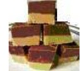 | fudge
3. |  | bridge
4. | 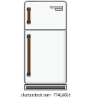 | fridge
5. |  | walked (walk)
6. |  | ate (eat)
7. |  | saw (see)
8. |  | opened (open)
9. |  | morning
10. |  | happy
11. |  | office
12. | 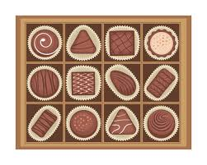 | box of fudge
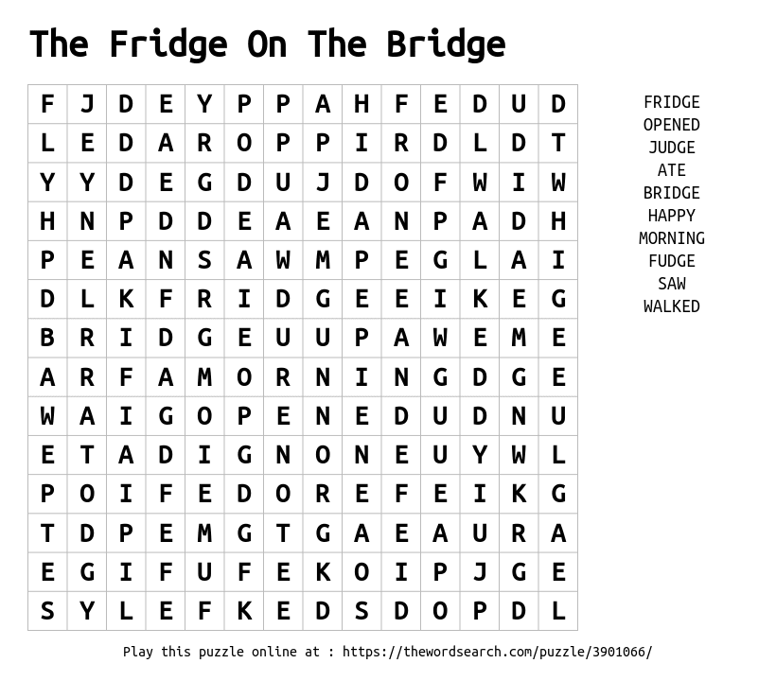
Word Search

