Lady in Labor

|  |  |
| --- | --- |
| The lady is a tutor, not an actor.      The father is a tailor, not a sailor. | The lady is in labor.    The lady calls for a doctor. |
| The father wants to be a visitor. | But the elevator operator isn’t working. He says, “No, take the stairs!” |
| The elevator would have been faster. The father missed the labor. But he brings ice cream…  though the color does not match the flavor. | The lady is sad.      She says, “See you later, alligator!” |

**Word List**

|  |  |  |  |
| --- | --- | --- | --- |
| 1 |  | doctor |  |
| 2 |  | color / colour* |  |
| 3 |  | alligator |  |
| 4 |  | actor |  |
| 5 |  | flavor / flavour* |  |
| 6 |  | labor / labour* |  |
| 7 |  | tutor |  |
| 8 |  | sailor |  |
| 9 |  | elevator |  |
| 10 |  | visitor |  |
| 11 |  | operator |  |
| 12 |  | tailor |  |

*-our is the British spelling for these words

Wordsearch

Use the images on the following page to find their corresponding words.

All of the words are found in the story. They were also taught in previous lessons.

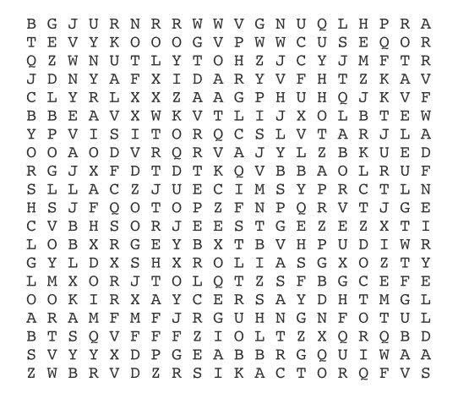

**Find these words in the wordsearch:**

|  |  |  |
| --- | --- | --- |
|  |  |  |
|  |  |  |
|  |  |  |
|  |  |  |
|  |  |  |
|  |  |  |