Rose is Home p. 1
Rose is home.  Rose is home. | Rose is home.
Rose is sad. Rose is alone. | 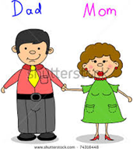  She hopes her mom and dad come home.
Bam. Bam. Did someone fall? | 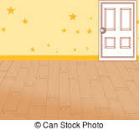  Yes? No? Rose doesn't see anyone at all.

Rose is Home p. 2
Rose's dog came home!  Rose's dog came home! | Rose's dog can find his bone.
Go get the ball, dog! | Go get the bone, dog!
Rose is not alone.  Her dog is home! Her dog is home! | Rose has a friend. Her dog is home

Word List
1 |  | Rose
2 |  | home
3 |  | dog
4 |  | bone
5 | 1 | one
6 |  | cone
7 | 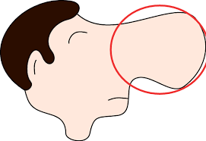 | nose
8 | 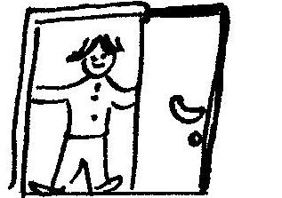 | come
9 |  | dogs
10 |  | alone
11 |  | close
12 |  | hole

Puzzle
The puzzle is in the next PDF document on the Hickey website.

Preparation:
Glue the sheet of puzzle pieces onto a stiff background, or laminate, and cut out.
Possible enhancements :
- You can paste a picture on the back of the whole jigsaw diagram, then cut up the separate puzzle pieces and glue them onto the diagram, then cut up the pieces again, so that when the puzzle is completed the student has made a picture.
- See the link on the last page of the puzzle PDF – there are templates available for different sized puzzles, so you can have as few or as many words as you want.
Play
1) Place the page with the puzzle background on the table (for more guidance, if appropriate, depending on the student) or let the student assemble the puzzle without that extra guidance.

2) Turn the 9 puzzle pieces upside down on the table.

3) Student picks up a puzzle piece, turns it over, and reads the word. If he reads it correctly he places it in the puzzle. If it's incorrect, he turns the piece over and puts it back down.

4) If necessary rearrange the pieces so the student doesn't memorize where the pieces are.

5) If the student picks up the same word he has just read it doesn't count and the piece is returned to the pile.

6) The game is over when the puzzle is completed.

