A Short Sports Story
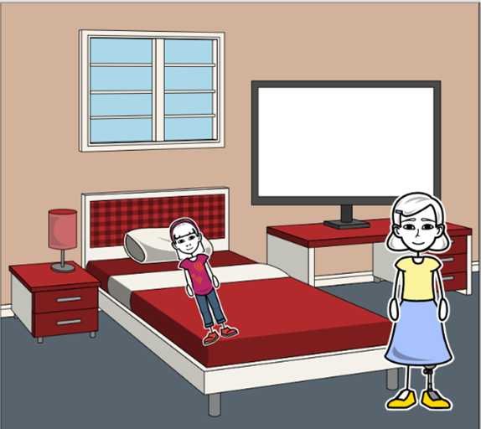  “Good morning, Jane. Don’t forget, it’s an important sports day today.  Get up and go!” | 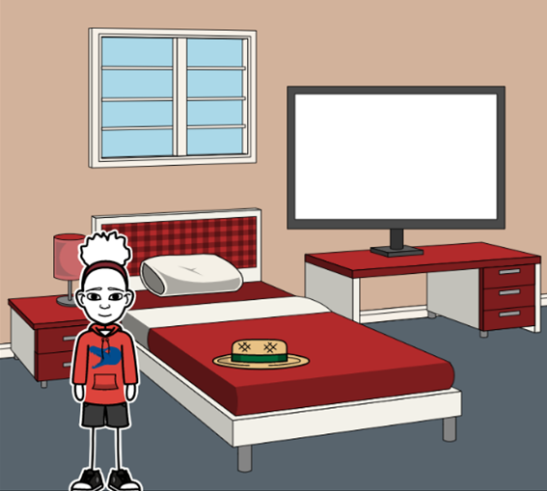  “I’ll dress in short pants and my green hat. It’s important, it’s hot today!”
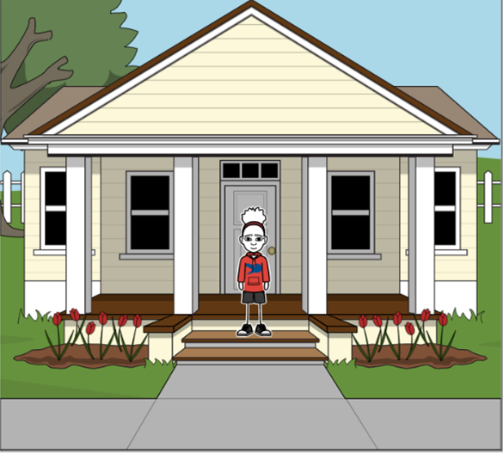  “This morning won’t be boring. You won’t be bored, for sure!” | 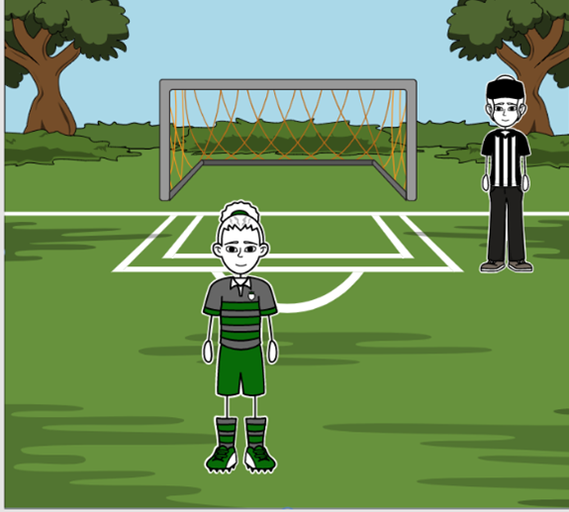  “No, it isn’t a normal ordinary day! Sports are fun!  I like football! There is order in this game. It’s not boring,” Jane said.
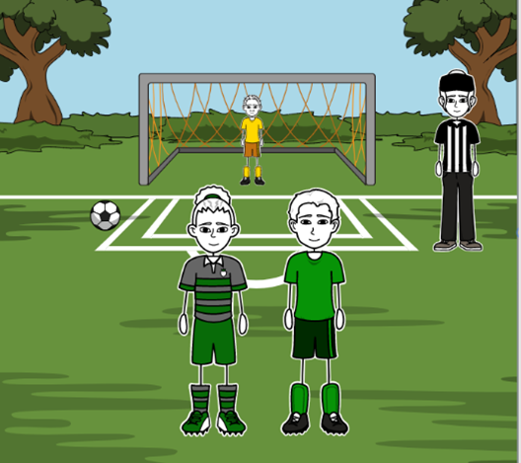  The ball was in the corner. “We need to kick the ball into the goal, even from the corner or we lose,” Jane said. | 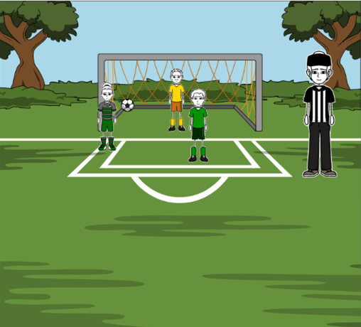  Andddd… “GOAL!!! Yes! I did it! I won!” Sports Day was fun!

Word List
1 |  | morning
2 | 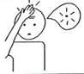 | forget
3 |  | important
4 | 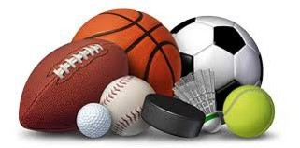 | sport
5 | 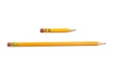 | short
6 |  | boring
7 | 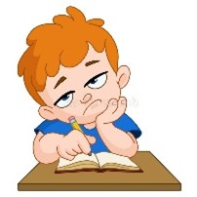 | bored
8 |  | for
9 | 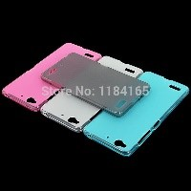 | normal, ordinary
10 | 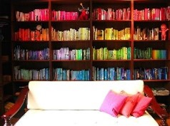 | order
11 |  | corner
12 |  | or

Matching Game
This is a more sophisticated form of “concentration” because it includes a self-check and hints on words that the learner doesn’t know.

Cut out the squares on the dotted lines only (don’t cut out the triangles).

To play: match the words, placing them together (the edges of their squares touching). Assemble the puzzle into a 3X3 square so that every word only touches a matching word.
(There are lots of “right ways” to assemble the puzzle, since the words at the top and bottom of each column and both ends of each row also match.)

sport  חשוב morning  או | short  בוקר forgets  פינה | boring  שוכח important  סדר
or  נורמלי bored  טוב | corner  משועמם for  מכנסיים | order  בשביל normal,  ordinary  ירוק
good  כיף today  ספורט | pants  היום football  קצר | green  כדורגל fun  משעמם

Link to online game: https://wordwall.net/resource/15173681

