Tamar's Party and the Stars
Tamar and her friends are at a bar. It's Tamar's party at the bar and Tamar is the star! | Many friends are there.  Tamar's friend Ari sits beside her.  "It's present time!" said Ari.
All Tamar's friends hand her many presents. She is happy. | Tamar had a cake in a star shape, and they all ate cake.
Then Tamar said, "I like the stars! Let's ride to a park by car!"  Tamar, Ari and all their friends ride far in their cars. | At the park, the sky is dark.  There are many, many stars. They all like the stars in the black, black sky. And that's the end of Tamar's party!

1 |  | bar
2 | 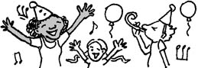 | party
3 | 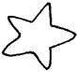 | star
4 |  | dark
5 | 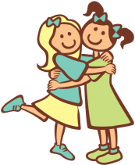 | friends
6 | 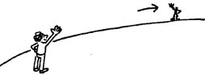 | far
7 | 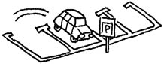 | park
8 |  | hands
9 | 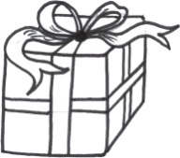 | present
10 | 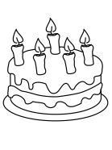 | cake
11 |  | happy
12 | 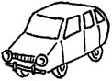 | car

Snakes and Ladders
To connect this game to the story, each time that the players land on a ‘snake’ or ‘ladder’, they have to correctly answer one of the questions below. If it’s a snake and they answer correctly- they don’t have to move back, and if it’s a ladder- they have the permission to move up.
You’ll need a dice for this game. Note: Together with your learner, you can think of more questions to ask, and you can choose the ones from the list that are easier for the learner.
Good luck!

Questions:
- Where are Tamar and her friends?
- Who is the star of the party?
- How old is Tamar?
- Who is Tamar’s friend?
- How does Tamar feel?
- What is the shape of the cake?
- Where are they riding to?
- Describe the sky in the story

