**Word List**

|  |  |  |  |
| --- | --- | --- | --- |
|  | who | Who Icon – Free Download, PNG and Vector | 1 |
|  | which | What Icon – Free Download, PNG and Vector | 2 |
|  | wherever | C:\Users\user\AppData\Local\Microsoft\Windows\INetCache\Content.MSO\73A0E3E4.tmp | 3 |
|  | Whitney |  | 4 |
|  | Whiskers | 5 things that scare and stress your cat - Times of India | 5 |
|  | where | Where Icon – Free Download, PNG and Vector | 6 |
|  | when | Clock Icons - Download Free Vector Icons | Noun Project | 7 |
|  | other | Double Arrow PNG Images, Free Transparent Double Arrow Download , Page 2 -  KindPNG | 8 |
|  | Wendy |  | 9 |
|  | whistle | C:\Users\user\AppData\Local\Microsoft\Windows\INetCache\Content.MSO\ED3609BC.tmp | 10 |
|  | Whitey |  | 11 |
|  | love | Heart icon - Evil Icons | 12 |

**Crossword Puzzle: Where's Whitey?**

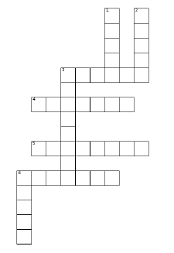

**Crossword Puzzle: Where's Whitey?**

**Answer Key**

