Tim and his Bike
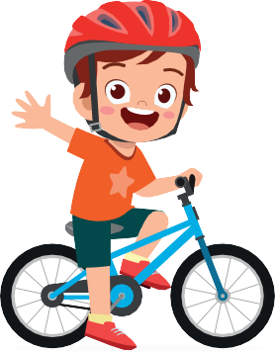  Tim dresses himself in a red helmet. Tim rides his bike. Tim is tireless. He happily rides and rides. | 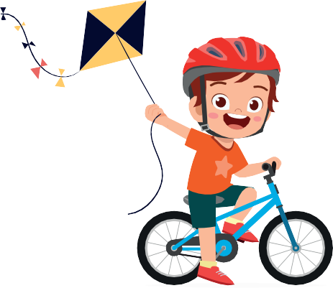  Tim has a kite in his hand as he rides.  That is careless!
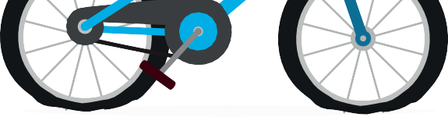  Can he ride as a kite is in his hands? He can't!  Tim rides carelessly, and,,, the bike's tires are flat! | 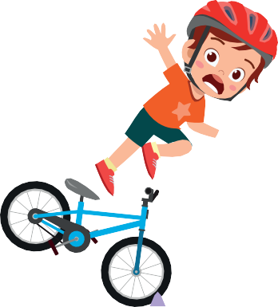  Sadly, he falls. Happily, he has a helmet! He is fine. The kite rises. It can fly in the sky! Finally, he stands.
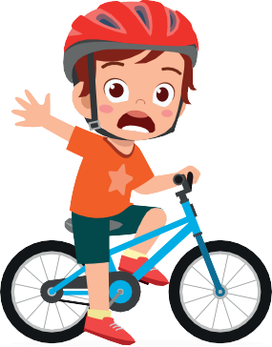  Tim is kiteless.  His kite is in the sky. | 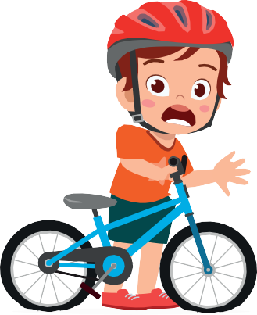  Tim's bike's tires are flat.  He hikes sadly and tiredly beside his  bike.

Word List
1 |  | dresses
2 |  | helmet
3 |  | bike
4 |  | rides
5 |  | tireless
6 |  | kite
7 |  | careless
8 |  | sadly
9 |  | happily
10 |  | rises
11 |  | hikes
12 |  | tiredly

Game to print and play on paper:

Unscramble the following words.

1. | dsseers
2. | heemlt
3. | ebik
4. | rside
5. | tileress
6. | ekit
7. | clesares
8. | dlysa
9. | hpilypa
10. | hiske
11. | tdreily
12. | sries

Online Game:

Online Wordwall game: Tim and his bike.
Please click on the link below to access the online game.

https://wordwall.net/resource/31170393

