Dad and Ant
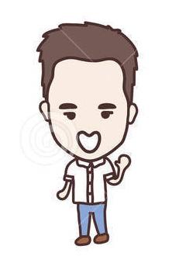  This is Dad, hi Dad! | 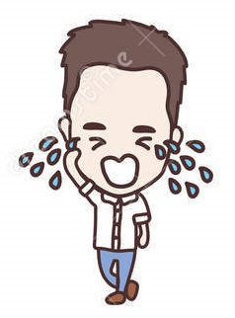  Dad is sad.
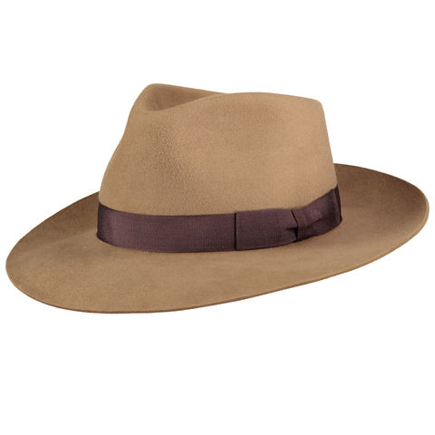  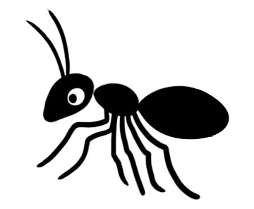  This ant is in his hat! | 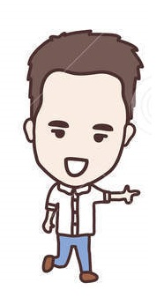  Dad hits this ant.
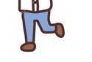  This ant hits his pants. | Ant hits sand, Dad isn't sad!  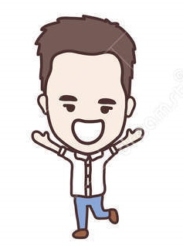  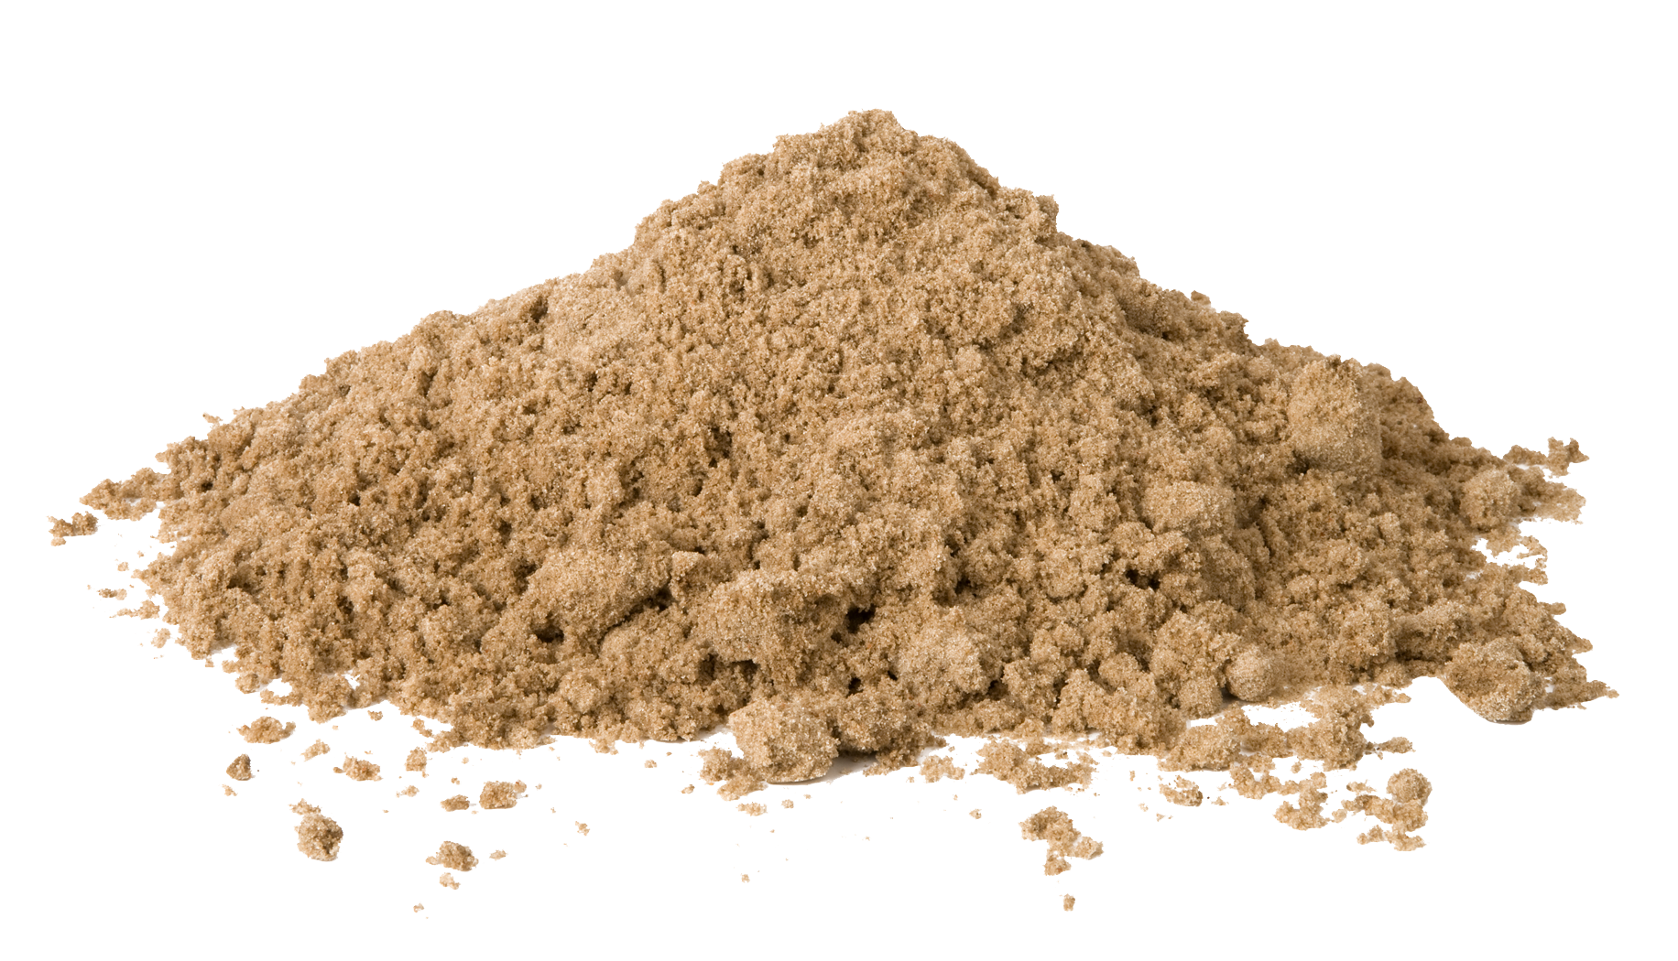

Word List
1 |  | Dad
2 | 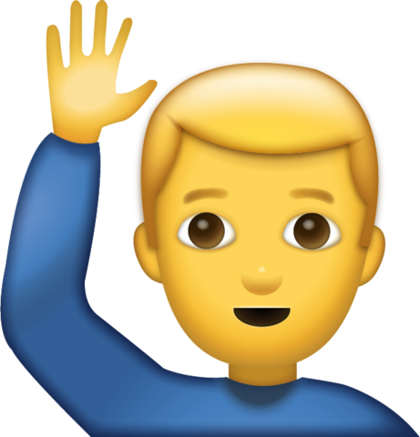 | hi
3 |  | sad
4 | this | this
5 |  | ant
6 |  | hat
7 | 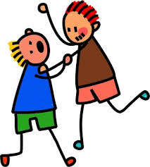 | hits
8 | 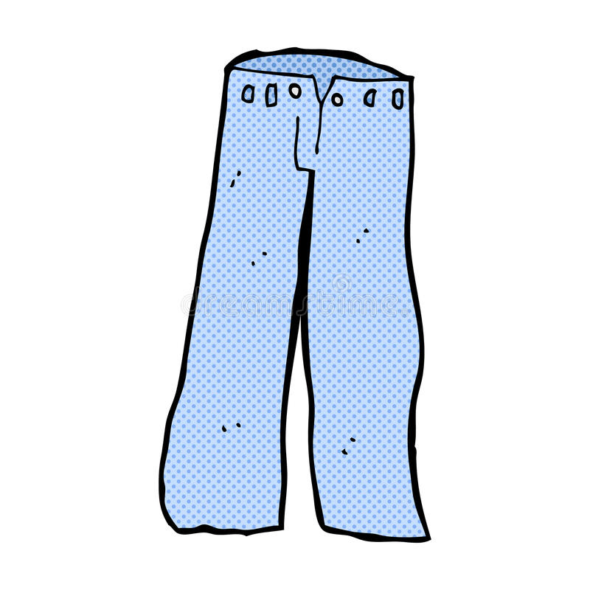 | pants
9 |  | his
10 |  | sand
11 | Is | is
12 | Is not | isn't

Game:
Memory game- cut out the pictures and their definitions and turn them over. Take turn with a friend and try to find pairs! Use the arrows to check yourselves. If they match perfectly, you are right!
Good luck!

 | Dad
 | hi
 | sad
this | this
 | ant
 | hat
 | hits
 | pants
 | his
 | sand
Is | is
Is not | isn't

