Nathan and his Dad
Nathan and his Dad stand in a path.  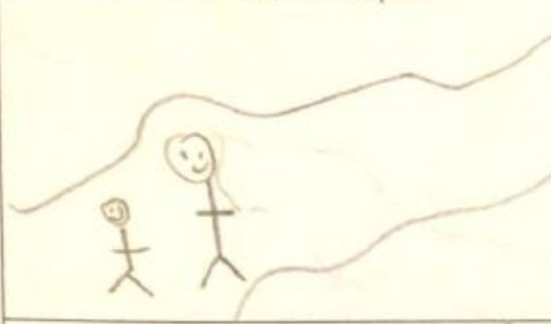 | This path has sand.  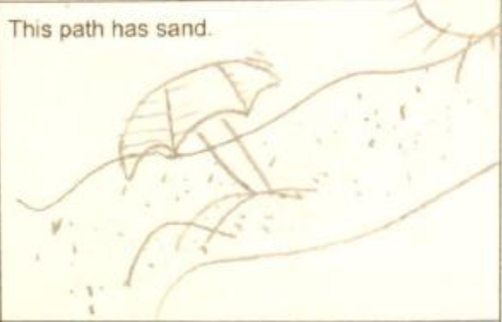
Nathan sits and pats that sand.  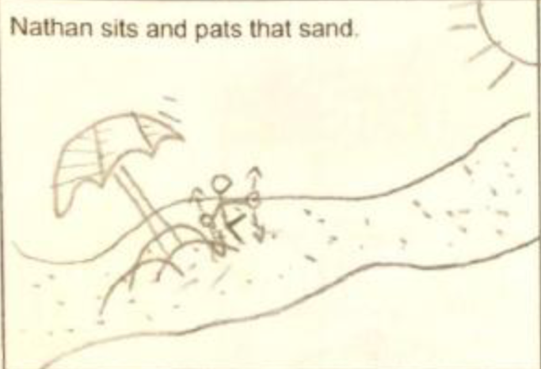 | Sand is in his pants.  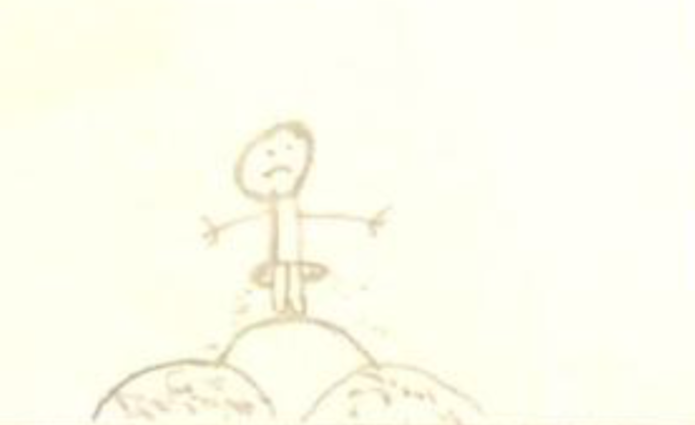
Dad hits the sand in Nathan’s pants.  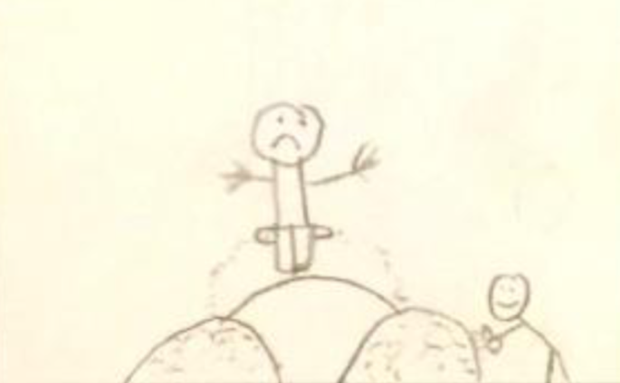 | Nathan is sad.  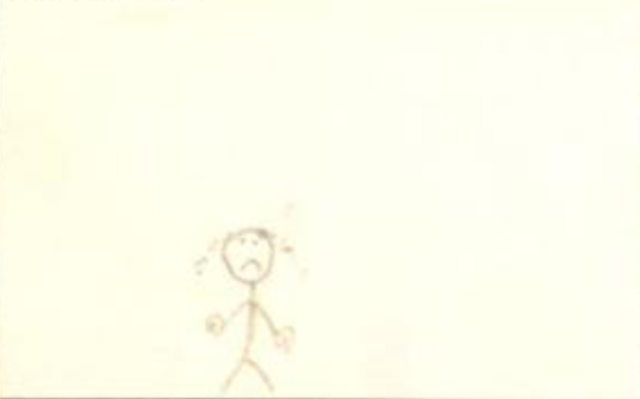

Dad isn’t as sad as Nathan.  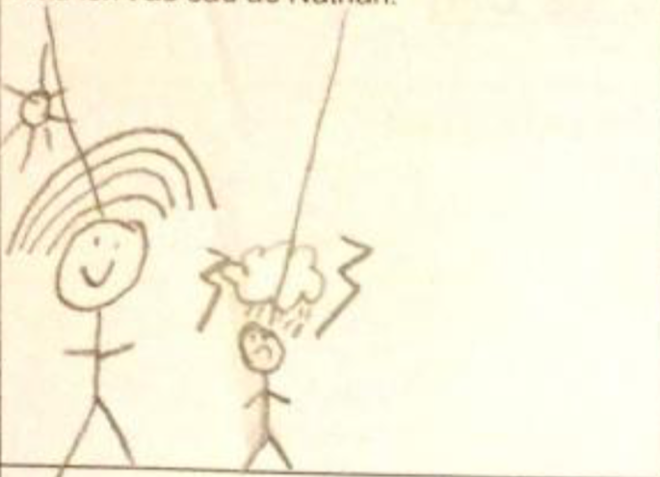 | Dad hands Nathan sand in his hat.
“This sand has thin pins in it.”  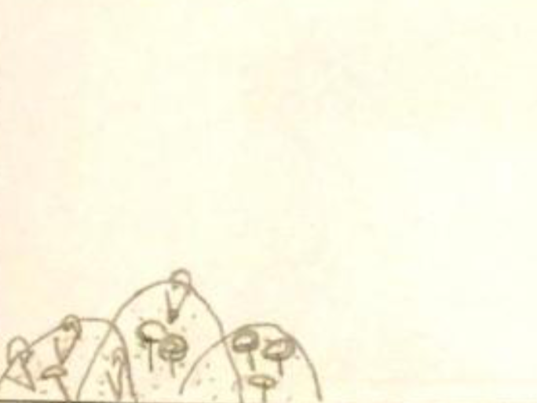 | Dad hit the sand. He didn’t hit Nathan.  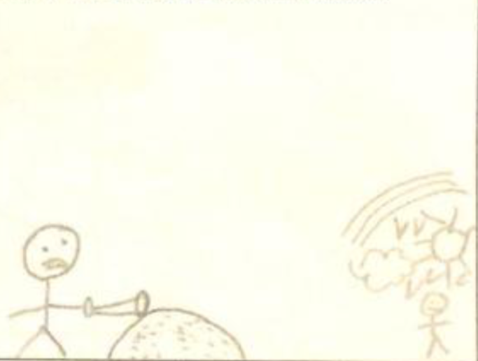
Nathan and his dad stand hand in hand.

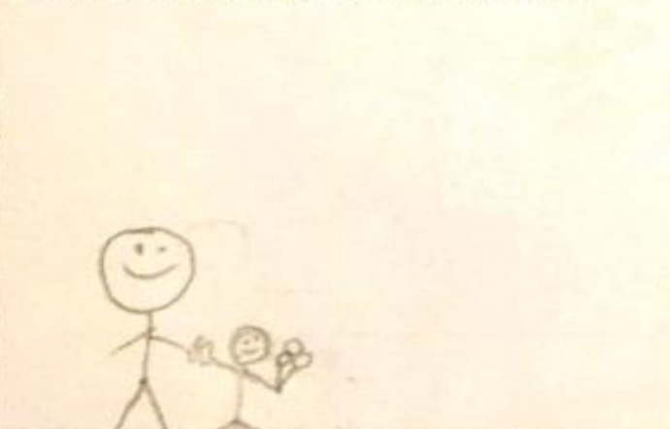

Word List
1 |  | Nathan
2 | 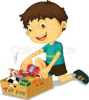 | his
3 |  | path
4 | 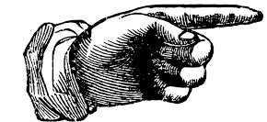 | this
5 | 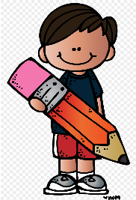 | has
6 |  | that
7 | 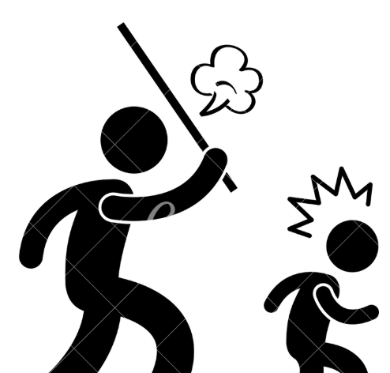 | hit
8 |  | sand
9 |  | hands
10 |  | hat
11 | 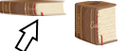 | thin
12 |  | pins
Word Search
J | O | E | J | T | Z | Q | D | D | H | A | Z | A | D | A
Z | Z | I | K | J | R | D | X | N | I | I | X | J | Y | E
O | I | P | N | I | H | T | Q | X | N | I | H | X | G | S
A | N | N | W | Y | T | C | S | F | T | I | S | A | G | O
R | P | R | X | F | T | G | F | H | S | D | W | T | L | O
U | Y | P | D | E | O | S | G | S | N | Q | T | I | L | H
D | Y | F | I | T | H | I | S | A | J | A | K | S | Q | Q
R | N | A | T | H | A | N | H | S | H | A | L | P | A | T
E | U | O | Y | M | N | N | T | T | R | Q | T | J | H | P
E | B | T | A | V | Q | A | T | B | T | W | N | C | F | C
P | H | W | M | C | N | K | Z | Y | O | Z | D | Y | I | S
R | A | I | H | D | H | A | N | D | F | U | I | R | X | W
P | A | T | T | Z | U | S | N | E | Z | Q | D | F | B | D
L | L | M | H | S | I | K | Z | W | S | H | D | P | Z | U
H | T | L | P | M | K | Q | Y | A | C | Q | A | T | L | S
A | M | G | Z | F | X | R | T | A | S | C | D | S | R | U
T | J | M | N | Z | Y | P | W | D | C | N | F | F | A | L
DIDNT HAND HANDS THIN HITS
HAS HAT HINT HIS NATHAN
PATH THIS SAT SIT STAND
THAT

Word Search SOLUTION
+ + + + + + + + + H + + + + +
+ + + + + + + + + I + + + + +
+ + + N I H T + + N + H + + +
+ + + + + + + + + T I S + + +
+ + + + + + + + + S D + T + +
+ + + + + + + + + N + T I + +
+ + + + T H I S A + A + S + +
+ N A T H A N H S H + + + + +
+ + + + + + + T T + + T + + +
+ + + + + + A + + + + N + + +
P H + + + N + + + + + D + + +
+ A I + D H A N D + + I + + +
+ + T T + + + + + + + D + + +
+ + + H S + + + + + H + + + +
H + + + + + + + + + + A + + +
A + + + + + + T A S + + S + +
T + + + + + + + + + + + + + +

Word (Cell number Over, Cell number Down, Direction)
DIDNT(12,13,N)
HAND(6,12,E)
HANDS(8,8,NE)
HAS(11,14,SE)
HAT(1,15,S)
HINT(10,1,S)
HIS(12,3,SW)
HITS(2,11,SE)
NATHAN(2,8,E)
PATH(1,11,SE)
SAT(10,16,W)
SIT(13,7,N)
STAND(9,8,SW)
THAT(9,9,NE)
THIN(7,3,W)
THIS(5,7,E)

