Sky's Dry Bed
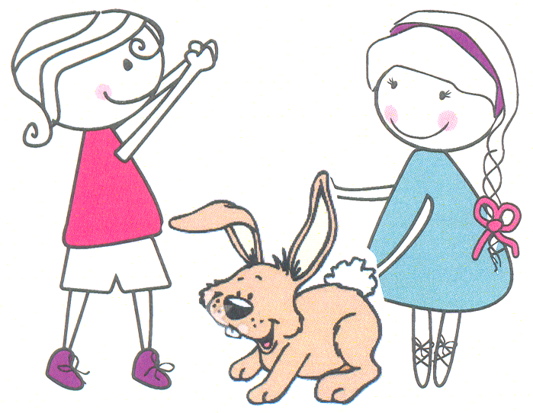  Kim and Ann had a little rabbit, Sky. | 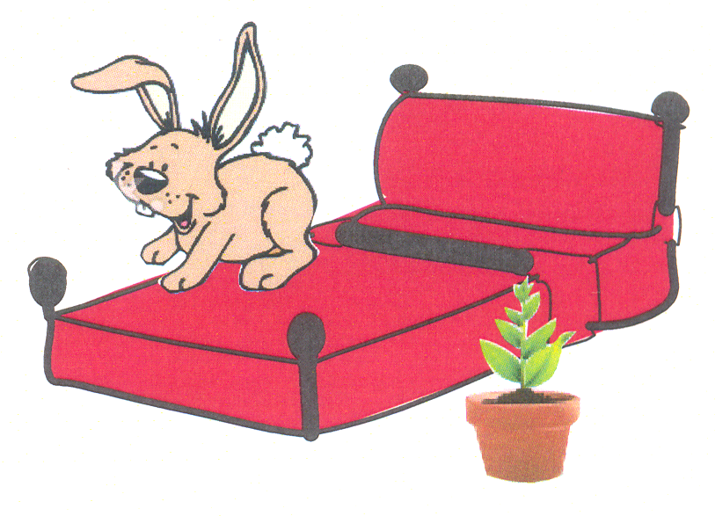  Sky slept in a red bed by a plant
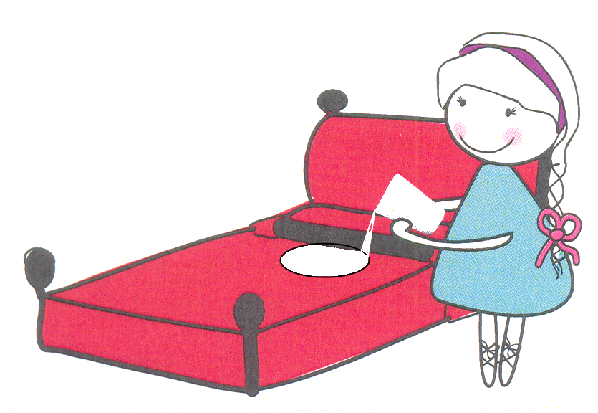  Ann spilt her milk in the bed. | 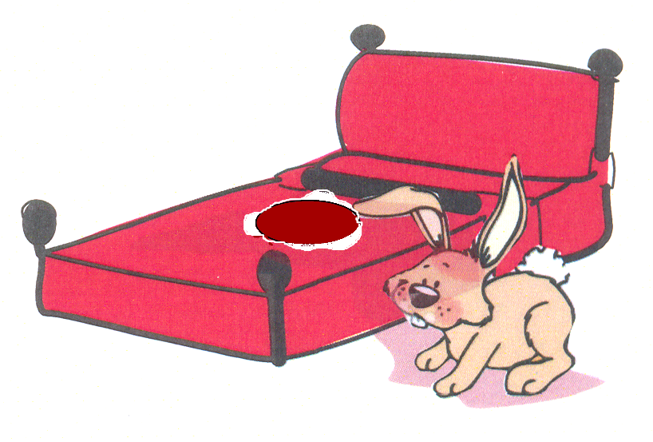  Sky yells a cry, “My bed isn’t dry!”
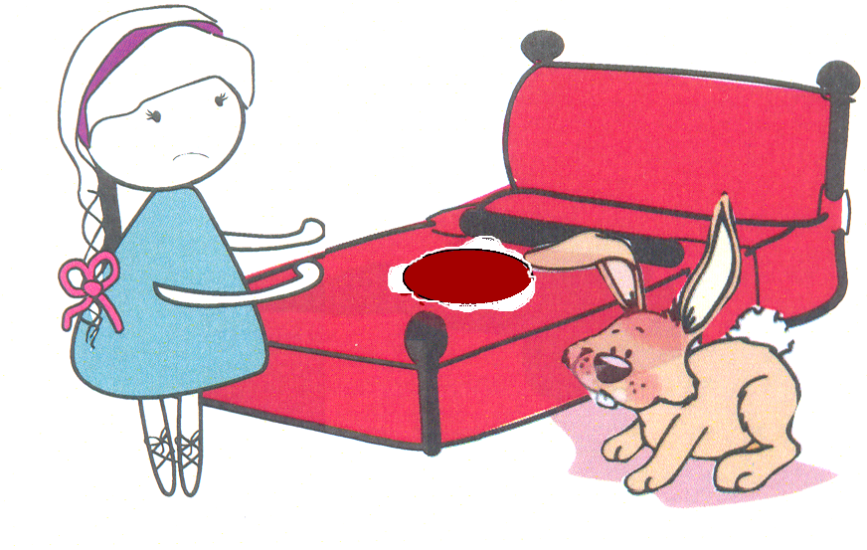  Sky is mad at Ann. “Dry my bed!” | 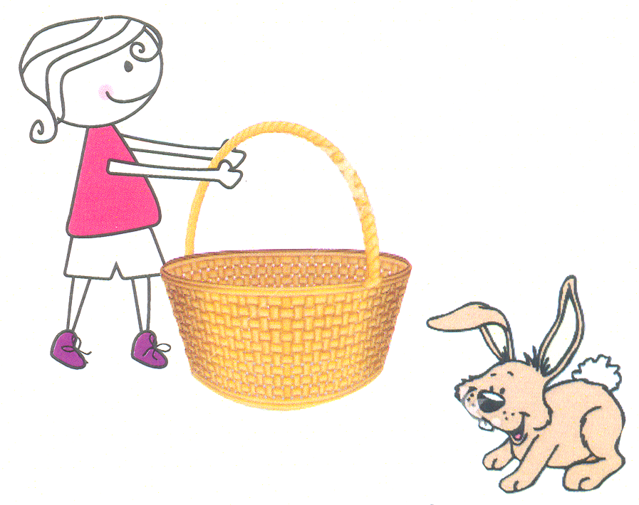  Kim finds Sky a basket that is dry.

Word List
1 | 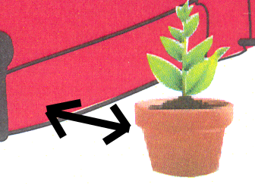 | by
2 | 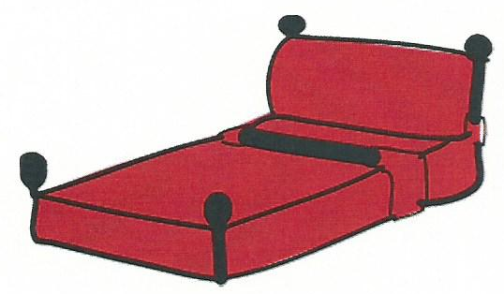 | bed
3 | 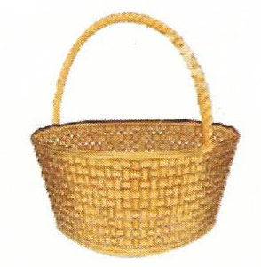 | basket
4 | 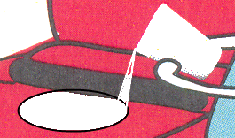 | spilt
5 | 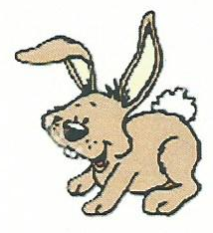 | Sky
6 |  | red
7 | 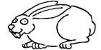 | rabbit
8 | 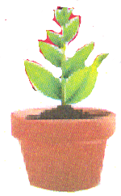 | plant
9 | 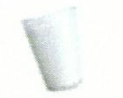 | milk
10 | 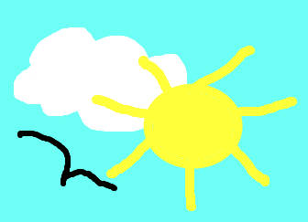 | sky
11 | 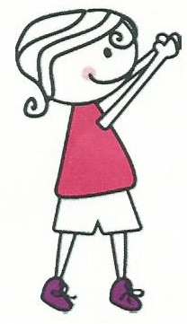 | Kim
12 | 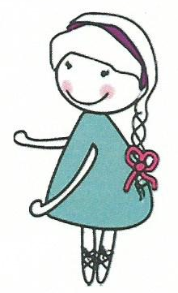 | Ann

Spin and Spell
Preparation: Make the spinner by cutting out and gluing the below circle of letters onto a plastic plate. Make a hole in the middle and attach the spinner arrow with a wire or paper clip (or buy one prepared). Glue either the b/w or color board onto stiffer paper (lamination optional). You need a marker to move along the board for each player and a die.

Play: Toss a die to move along on the board. After landing on square, learner spins the dial to get a letter. Learner says if the letter makes a word or not. If needed, refer to the list of possible words (below). If the letter makes a word, learner reads the word and explains its meaning. If the letter does not make a word learner chooses a letter that will make a word.

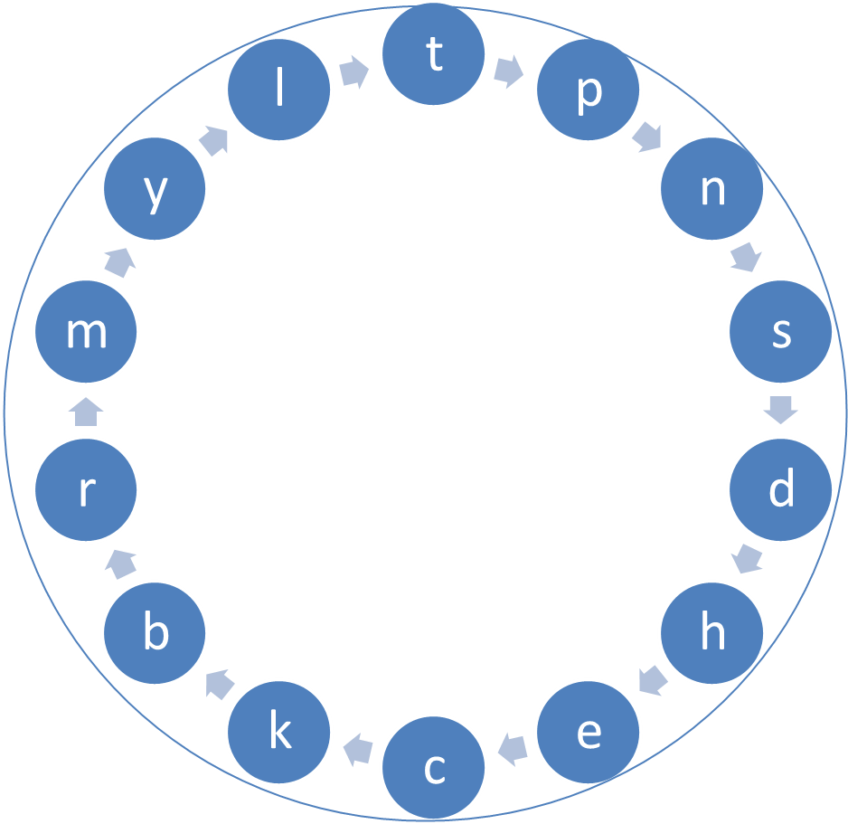

Spin and Spell
List of Possible Words
and | bell | did | last | pen | sand | tap
ant | bet | dry | like | pet | send | tell
as | bib | hen | milk | pick | sent | ten
ask | bill | hid | mine | picnic | she | tin
bad | bite | hide | my | pin | sip | tire
ball | call | him | nap | pit | sit | try
bat | can | is | neck | ran | skin | yes
be | cat | kick | nine | red | spy
bed | cry | land | pan | sad | talk



