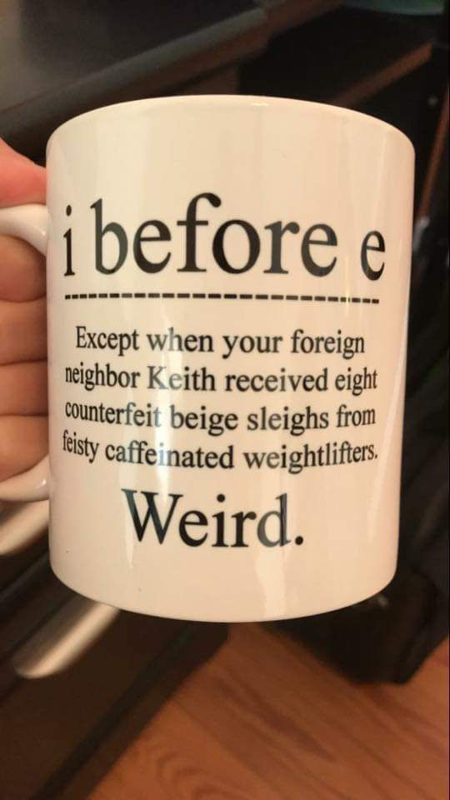

Here's the pattern:
“i” before “e”
except after “c”
(or when it sounds like “a”
as in “neighbor” and “weigh”).
*(in this lesson): or when it sounds like "e" as in "ceiling"

Q: Which of the "ei" words on this mug follow the pattern, and which are exceptions to the pattern?
A: ei words that sound like "a"

A: ei word with "ei" after "c"

A: ei words that are exceptions to the above pattern:
A: ei words that sound like "e" as in "ceiling":
Answer key:
Q: Which of the "ei" words on this mug follow the pattern, and which are exceptions to the pattern?
A: ei words that sound like "a"
neighbor
eight
beige
sleighs
weightlifters

A: ei word with "ei" after "c"
received

A: ei words that are exceptions to the above pattern:
foreign
counterfeit
feisty
caffeinated

A: ei words that sound like "e" as in "ceiling":
Keith
weird

Word origins of these exceptions:
from www.etymonline.com/word/
foreign: c. 1300, ferren, foran, foreyne, in reference to places, "outside the boundaries of a country;" of persons, "born in another country," from Old French forain, from Medieval Latin foraneus. English spelling altered 17c., perhaps by influence of reign, sovereign.
counterfeit: late 14c. (late 13c. in Anglo-French), countrefet; from Old French contrefait "imitated" (Modern French contrefait), past participle of contrefaire "imitate"
feisty: feist "small dog," earlier fice, fist (American English, 1805); short for fysting curre "stinking cur," attested from 1520s, with present participle of now-obsolete Middle English fysten, fisten "break wind" (mid-15c.), from Proto-Germanic *fistiz "a fart," said to be from PIE *pezd
caffeinated: from German Kaffein, coined by chemist F.F. Runge (1795-1867), apparently from German Kaffee "coffee" (see coffee) + chemical suffix -ine (2) (German -in). The form of the English word may be via French caféine

