Let’s Get a Puppy?
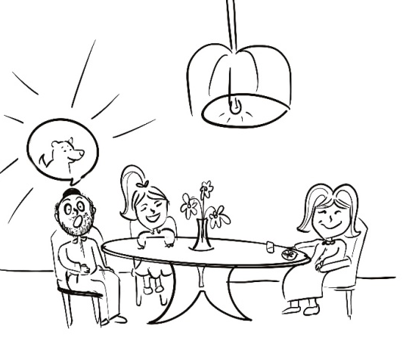  This morning my mother suggested to the family, “Let’s get a puppy!” My father replied, “What!?” | I was filled with amazement!  “Let’s go” I exclaimed!
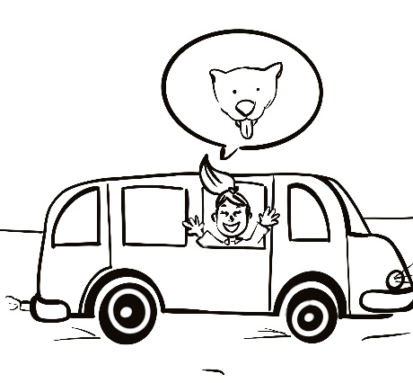  My mother and I traveled quickly to the pet store. The people on the bus were filled with amusement at my happiness. | The salesperson said, “Your home had better be indestructible! This puppy is adorable, but unteachable, destructive, and filled with craziness”.
My mother said, “This puppy is unworkable, I like a peaceful home”. | Our new hamster adores us already. He is much more manageable and agreeable. I am tying a ribbon around his cage.

Word List
1 | 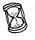 | suggested
2 |  | replied
3 |  | amazement
4 |  | quickly
5 |  | amusement
6 |  | happiness
7 |  | craziness
8 |  | manageable
9 |  | agreeable
10 |  | adores
11 | 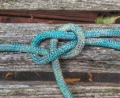 | tying
12 |  | said
Learning Suffixes – Go Fish (for single and multi-syllable words)
This game aims to practice the spelling rules with adding suffixes (-ing, -s, -ed, -er, -ent, -ful, -able, ly, -ous); the specific rules being taught are:
- Words with one syllable ending in consonant: double the consonant
- Words with more than one syllable ending in L: double the L
- Words ending with consonant + y: drop the y and add an i
- Words ending in ee or ye: no change
- Words ending in ie: change the ie to y
- Words ending in vowel + y: Keep the y
- Words ending in y + suffix beginning in i: keep the y
- Word ending in ce or ge + suffix beginning with a or o: Keep the final e
- Words ending with e + suffix beginning with a vowel: keep the e.
There is one family for each of these rules; you don’t need to play with all families but rather can choose according to your wishes for this class. Cut out the cards and paste them on to cardboard or laminate them. They can be printed in color to make it easier, or changed to black or white to make the game harder.
To play: Review the meaning of the suffixes in the game. Shuffle the cards. Deal each player four cards and put the remaining pile of cards face down in the middle. Players try to assemble families of four cards by asking the other player(s) for the card they want by name (example: “Do you have ‘joy - joyful’ from the ‘keep the y after a vowel family?”) If the player gets what s/he requested, she gets another turn. If not, the other player says, “No, Go Fish,” and the first player draws a card from the pile. Lay down each family of four cards as it is assembled; the learner should explain the meaning of the suffix, then read the 4 pairs of words and state their meanings. Play until all the cards are laid out in families. The player with the most families wins. (Try to let the learner outsmart you.)
One syllable ending in consonant: double the consonant  flip – flipped  swim – swimming  shop – shopped  fat - fatter | One syllable ending in consonant: double the consonant  swim – swimming  flip – flipped  shop – shopped  fat - fatter | One syllable ending in consonant: double the consonant  shop – shopped  flip – flipped  swim – swimming  fat - fatter | One syllable ending in consonant: double the consonant  fat - fatter  flip – flipped  swim – swimming  shop – shopped
Multi-syllable ending in L: double the L  control – controlling  cancel – cancelled  fulfill – fulfillment  propel -propeller | Multi-syllable ending in L: double the L  cancel – cancelled  control – controlling  fulfill – fulfillment  propel -propeller | Multi-syllable ending in L: double the L  fulfill – fulfillment  control – controlling  cancel – cancelled  propel -propeller | Multi-syllable ending in L: double the L  propel -propeller control – controlling  cancel – cancelled  fulfill – fulfillment
Ending with consonant + y: drop the y and add and i  beauty – beautiful  baby – babies  happy – happiness  army - armies | Ending with consonant + y: drop the y and add and i  baby – babies  beauty – beautiful  happy – happiness  army - armies | Ending with consonant + y: drop the y and add and i  happy – happiness  beauty – beautiful  baby – babies  army - armies | Ending with consonant + y: drop the y and add and i  army - armies  beauty – beautiful  baby – babies  happy – happiness
Ending in ee or ye: no change  agree – agreeing  see – seeing  eye – eyeing  free - freely | Ending in ee or ye: no change  see – seeing  agree – agreeing  eye – eyeing  free - freely | Ending in ee or ye: no change  eye – eyeing  agree – agreeing  see – seeing  free - freely | Ending in ee or ye: no change  free - freely agree – agreeing  see – seeing  eye – eyeing
Ending in ie: change the ie to y  die – dying  tie – tying  lie – lying  vie - vying | Ending in ie: change the ie to y  tie – tying  die – dying  lie – lying  vie - vying | Ending in ie: change the ie to y  lie – lying  die – dying  tie – tying  vie - vying | Ending in ie: change the ie to y  vie - vying  die – dying  tie – tying  lie – lying
Ending in vowel + y: Keep the y  joy – joyful  boy – boys  play – playing  enjoy - enjoying | Ending in vowel + y: Keep the y  boy – boys  joy – joyful  play – playing  enjoy - enjoying | Ending in vowel + y: Keep the y  play – playing  joy – joyful  boy – boys  enjoy - enjoying | Ending in vowel + y: Keep the y  enjoy – enjoying  joy – joyful  boy – boys  play – playing
Ending in y + suffix beginning in i: keep the y  worry – worrying  copy – copying  marry – marrying  carry - carrying | Ending in y + suffix beginning in i: keep the y  copy – copying  worry – worrying  marry – marrying  carry - carrying | Ending in y + suffix beginning in i: keep the y  marry – marrying  worry – worrying  copy – copying  carry - carrying | Ending in y + suffix beginning in i: keep the y  carry - carrying worry – worrying  copy – copying  marry – marrying
Ending in ce or ge + suffix beginning with a or o: Keep the final e  courage – courageous  notice- noticeable  change – changeable  advantage - advantageous | Ending in ce or ge + suffix beginning with a or o: Keep the final e  notice- noticeable  courage – courageous  change – changeable  advantage - advantageous | Ending in ce or ge + suffix beginning with a or o: Keep the final e  change – changeable  courage – courageous  notice- noticeable  advantage - advantageous | Ending in ce or ge + suffix beginning with a or o: Keep the final e  advantage - advantageous  courage – courageous  notice- noticeable  change – changeable
Ending with e + suffix beginning with a vowel: drop the e  drive – driving  hope – hoping  adore – adorable  use - user | Ending with e + suffix beginning with a vowel: drop the e  hope – hoping  drive – driving  adore – adorable  use - user | Ending with e + suffix beginning with a vowel: drop the e  adore – adorable  drive – driving  hope – hoping  use – user | Ending with e + suffix beginning with a vowel: drop the e  use - user  drive – driving  hope – hoping  adore – adorable

