Jenna Builds a Dumb Bomb
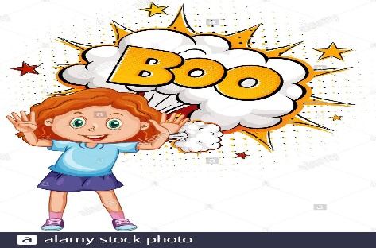    1. Jenna isn't dumb, but she wants to build a bomb. She thought it would be fun. "What could be wrong with that?" she thought. | 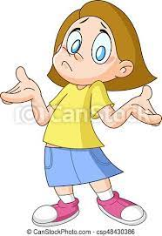  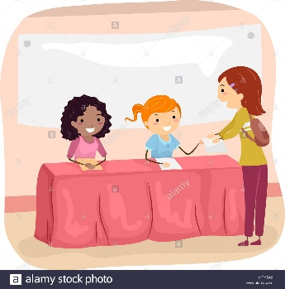  2. But she didn’t know how to make a bomb, so she found the table with the "Science Club" sign and signed up.
    3. She wrote to her mom that she wanted to build a bomb. Her mom was a chemist. She might help her build the bomb. | 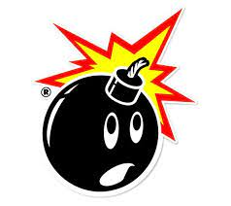  4. Her mom asked her, "Why do you want to build a bomb? That is a dumb idea!  A bomb is dangerous! It can explode and hurt someone!"
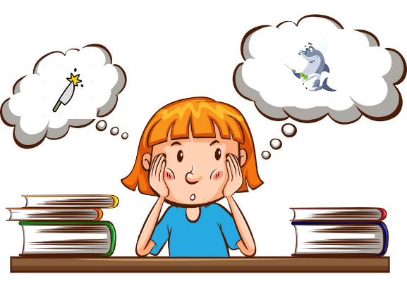  5. Jenna answered, "No! I am as smart as a shark and sharp as a knife. I want to make a bomb because I think it's fun and I know that I am right!" | 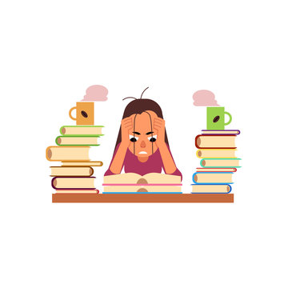  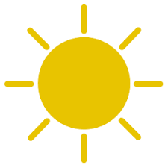  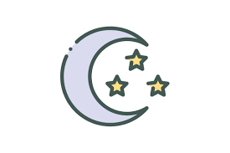  6. Then she worked hard, studied science every day and night, until the bomb was finished from left to right.  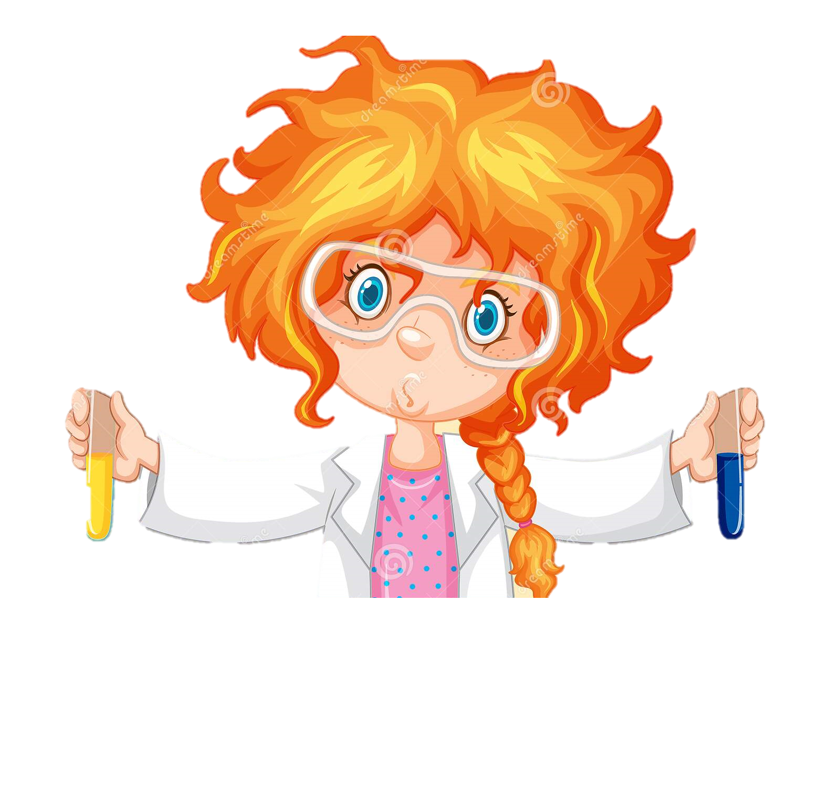  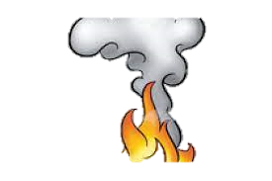
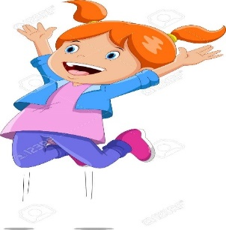    7. As she jumped for joy and almost climbed on the wall, the bomb fell out of her hands. It exploded right in her face. | 8.Luckily, she was not hurt, the bomb was not strong, but her hair was a mess. She sighed and acknowledged her mistake.  "I guess it was dumb to build a bomb. But I'm happy I learned some science!"

Word List
1 | 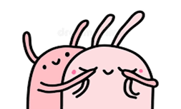 | guess
2 | 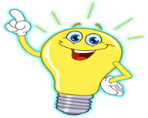 | know
3 | 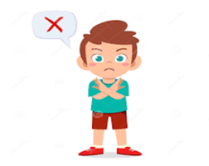 | wrong
4 | 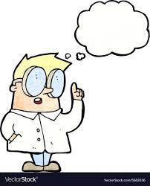  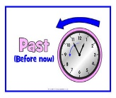 | thought
5 | 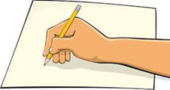 | write
6 |  | wrote
7 |  | science
8 | 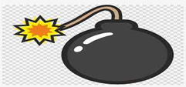 | bomb
9 | 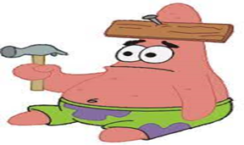 | dumb
10 | 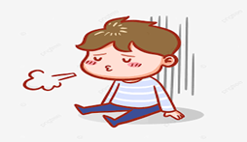 | sigh
11 | 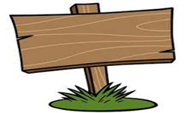 | sign
12 | 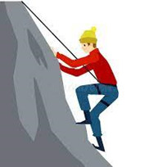 | climb

Game: Kahoot
Click on me
Or
https://create.kahoot.it/share/game-lesson-83/bcc5e8a6-30ac-42e6-98be-89d8a2edeb49
*Copy and paste the link to play online
Or
Print the next page to take the quiz on paper.

Tutor, read a word with a silent letter aloud and ask the student to mark the correct answer and underline the silent letter.

Words to read aloud to student, and answer key (underlined silent letter):
- guess
- talk
- dumb
- sign
- rhyme
- caught
- knew
- writes
- False, it is not a sign (it is a box).
- True, it is the correct spelling.
- True, this person is climbing.
Silent Letters Quiz
Mark the word the teacher says, and underline the silent letter.

-  rest pest guess nest
- song wrong long talk
- lamb numb dumb sum
- sigh sign pine sin
- rhyme time rain ride
- caught taught thought knot
- know knew show knife
- right knife night writes

True or False?

- This is a picture of a sign.
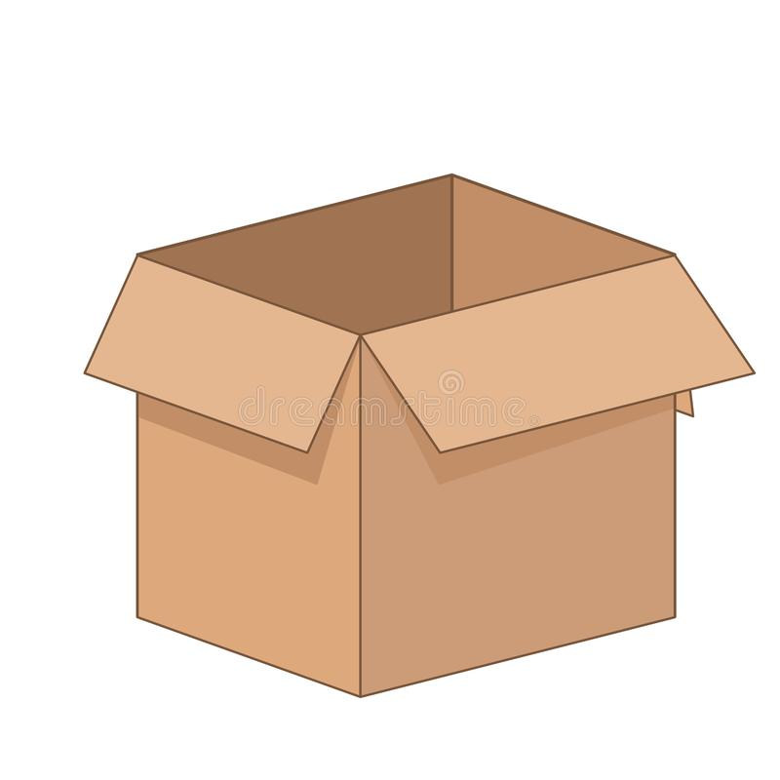 True, it is a sign. False, it isn't a sign.

- This is the correct way to spell the word "science."
True, it is correct. False, it isn't correct.

- This person is climbing.
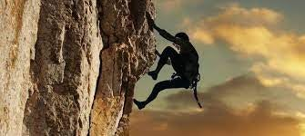 True, this person is climbing.
False, this person isn't climbing.

