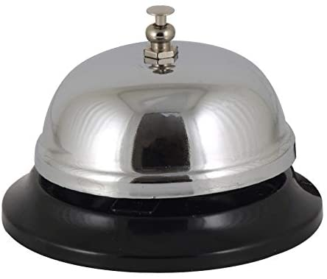**be_ _**

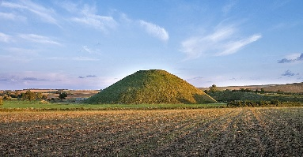 **h_l_**

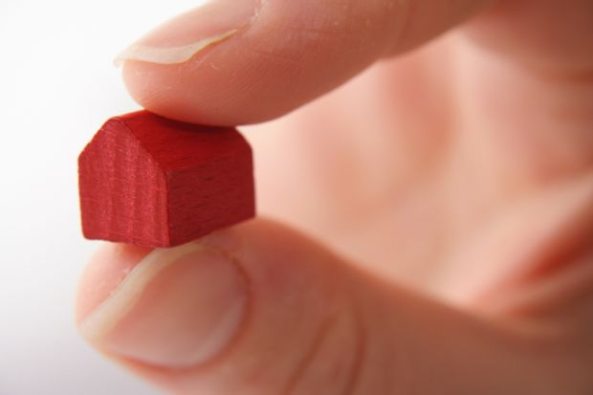 **sm_ _l**

 **y_l_**

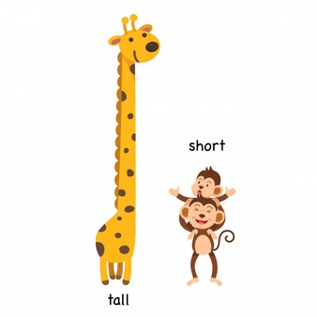 **t_l_**

 **p_ll**

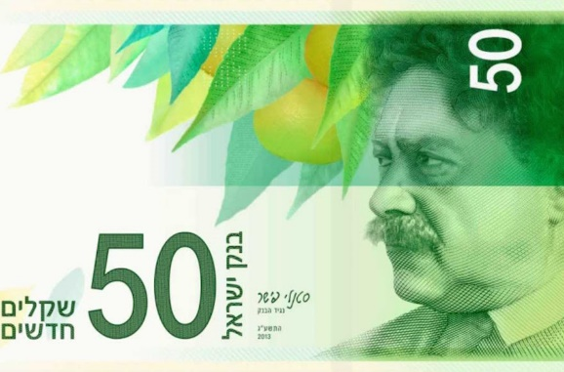 **b_ll**

 **s_ _ l**

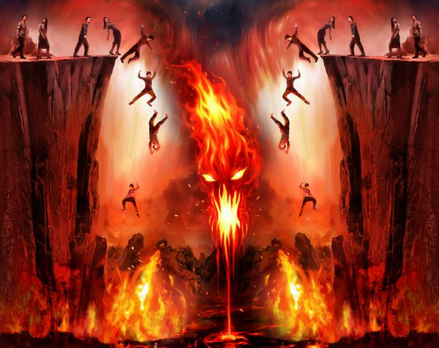 **h_ _l**

**answers (from top to bottom)**

**bell  
hill  
small  
yell  
tall  
pill  
bill  
sell  
hell**